Topic overview
Fake news refers to deliberately fabricated or misleading content presented as real news, while misinformation is false or inaccurate information that may be shared without harmful intent. Both spread rapidly because of algorithms that reward engagement, anonymous accounts, and the low cost of publishing content online.
Digital forensics brings systematic methods to collect, preserve, and analyze digital traces behind such content, treating fake news incidents as evidence-driven investigations rather than just media problems. This includes examining messages, metadata, network patterns, and platform behavior to reconstruct how a story started, evolved, and impacted users.
- Explosive spread of fake news: Online platforms allow false or manipulated information to reach millions of users within minutes, faster than it can be verified or corrected.​
- Difficulty of detection: Fake news often mixes true facts with misleading context, images, or headlines, making purely manual fact‑checking and traditional filters inadequate.​
- Attribution and traceability challenge: It is hard to reliably trace the original source, bots, and coordinated networks behind misinformation campaigns across platforms and jurisdictions.​

- Scale and data complexity: Social media and news streams generate massive, high‑velocity, and unstructured data, which requires scalable storage and analysis infrastructure (e.g., distributed databases like Cassandra) to perform any meaningful forensic investigation.​
- Integrity and preservation of evidence: Posts can be edited, deleted, or hidden, which complicates preservation of digital evidence and maintaining a clear chain of custody for legal or academic investigations.​
- Real‑world impact: Misinformation affects elections, public health, security, and individual reputations, creating urgency for reliable forensic methods rather than ad‑hoc debunking.​

Core problem statement
The core problem is that fake news and misinformation can be created and amplified at massive scale, while investigators struggle to trace their origin, verify authenticity, and attribute responsibility in a reliable and legally defensible way. Existing detection methods must handle huge volumes of data, fast-changing narratives, and sophisticated actors who actively try to evade filters and fact-checking.
From a forensic perspective, the challenge is to design pipelines and tools that can ingest large social media or news datasets, store them efficiently (for example in distributed databases such as Cassandra), and support complex queries that reveal patterns of coordination, timing, and anomalous behavior. Your Docker-based Cassandra setup demonstrates how containerized, scalable data infrastructure can support this type of investigation by making it easier to deploy, isolate, and experiment with forensic workloads on misinformation datasets.

The primary objective :
To provide a scalable, forensically sound platform that ingests, stores, and analyzes large volumes of social media/news data in order to detect, trace, and understand fake news and misinformation.
In your report, you can break this into 3–4 clear points like this:
- To collect and store misinformation-related data in a structured way using Cassandra, so that evidence is preserved for repeatable forensic analysis.
- To support complex queries and pattern analysis (e.g., source identification, propagation paths, abnormal user behavior) over large datasets efficiently using a distributed database.
- To enable reproducible experiments by running the entire stack in Docker, making deployments isolated, consistent, and easier to audit from a forensic perspective.
- To ultimately assist investigators and researchers in identifying origins, spread patterns, and impact of fake news, rather than just detecting single false posts.

CHAPTER-2
CASSANDRA AND KEYSPACES
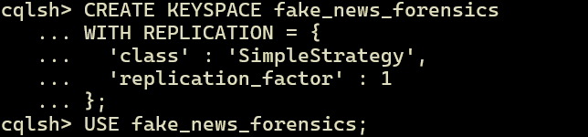
creating and selecting the “fake_news_forensics keyspace” for the fake news forensic analysis system.
Create Core Tables:
TABLE-1: Store news posts
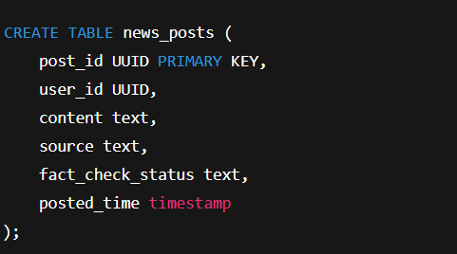

INSERT 10 QUERIES INTO THE TABLE:
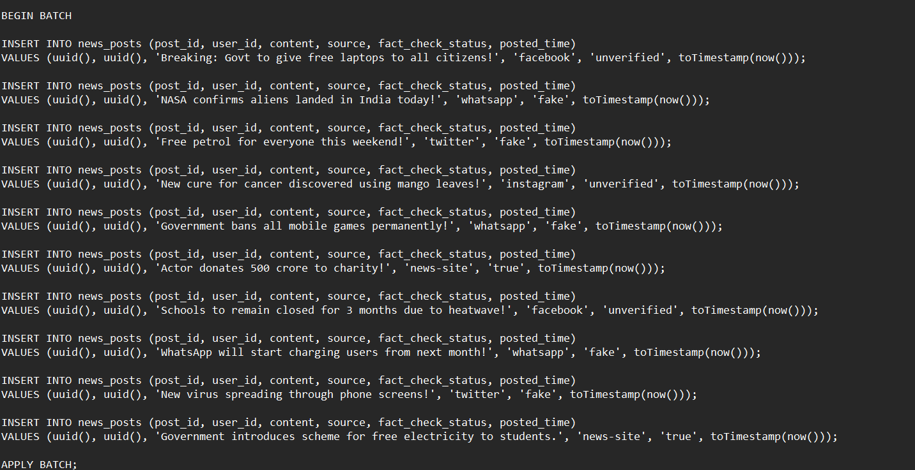
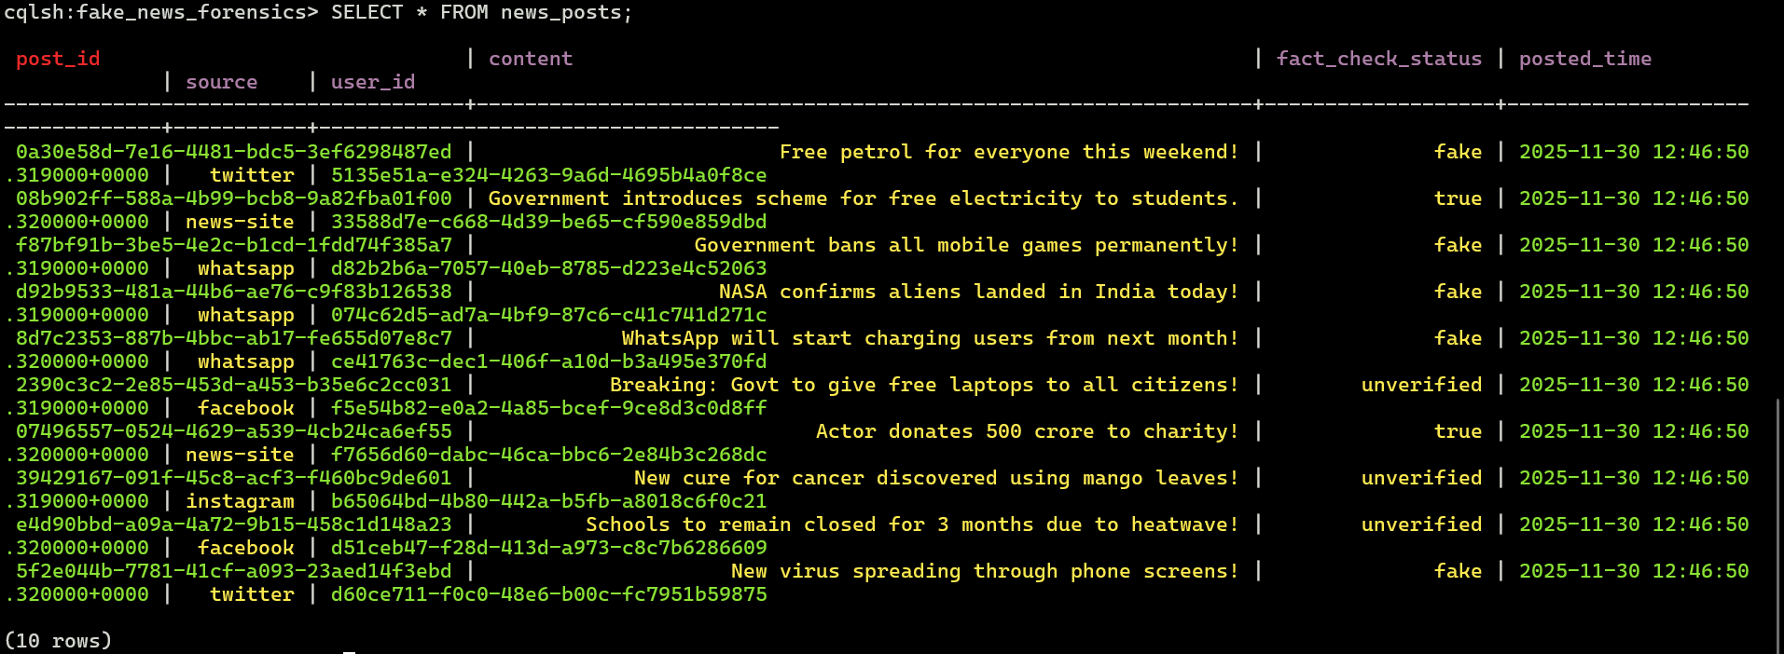

TABLE-2 Store fact-checking results
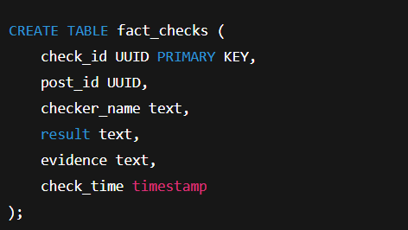
INSERT 10 QUERIES INTO THE TABLE
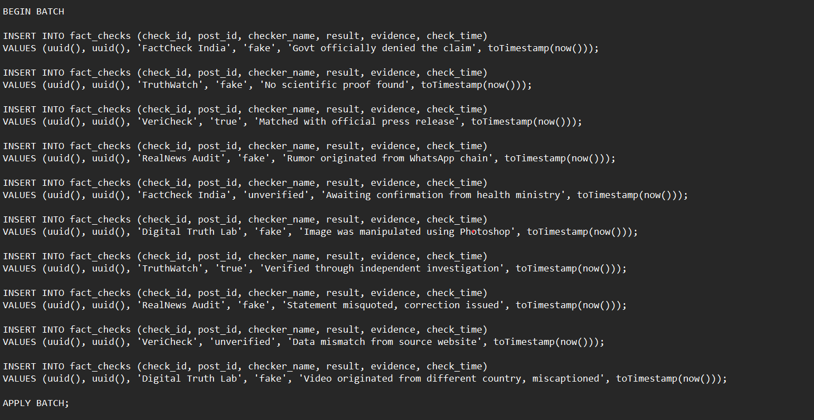

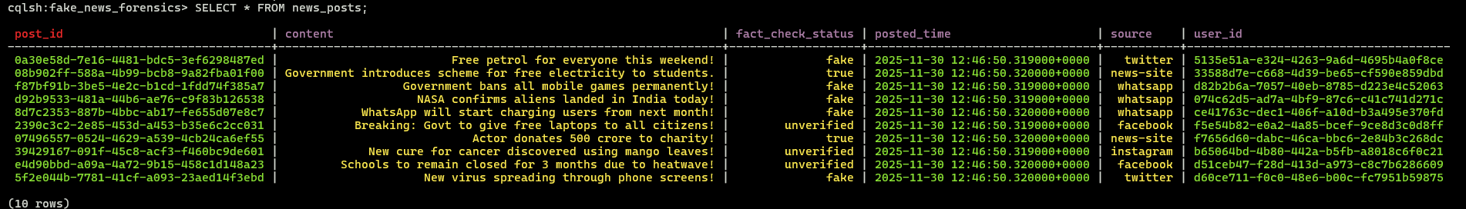

TABLE-3 : Track spread of fake news
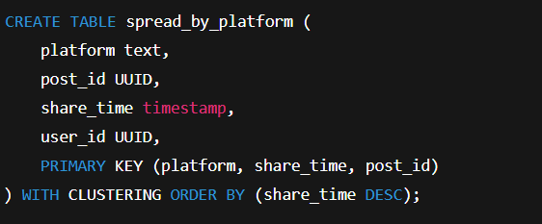
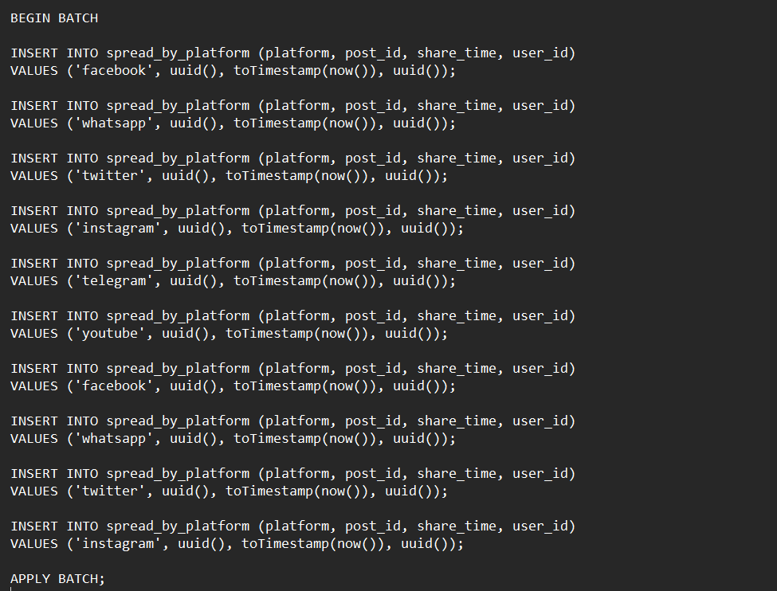
INSERT 10 QUERIES INTO THE TABLE

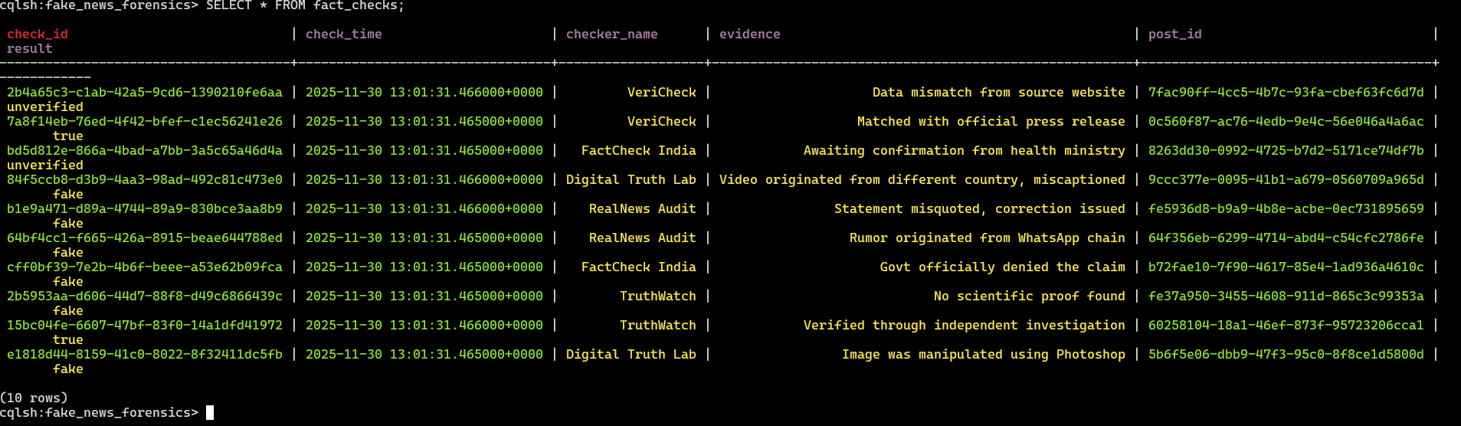

Forensic Investigation Queries
A) Find all posts marked fake

B) Get all fact-checks for a specific post
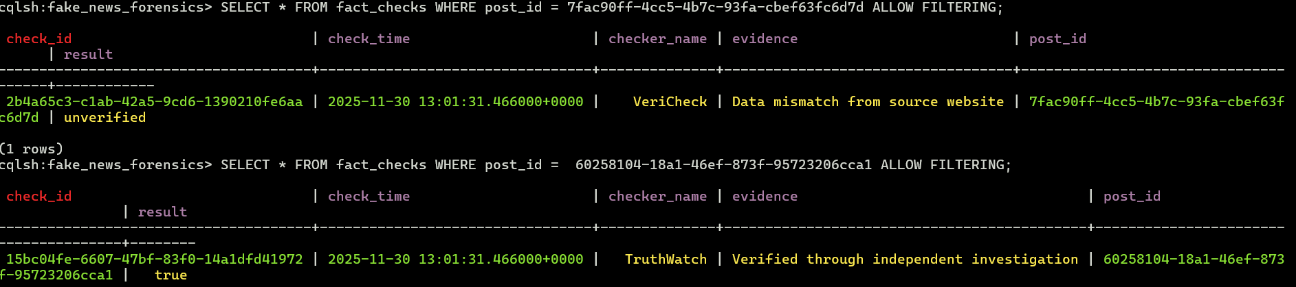

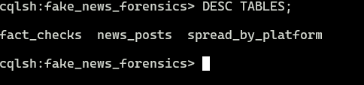

7 Investigation Timeline Query:
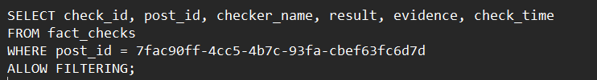

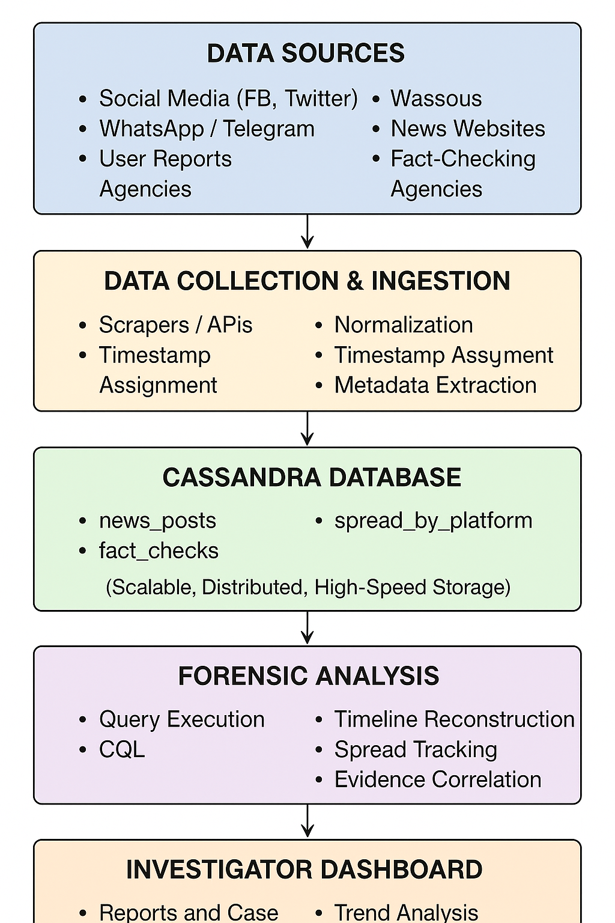

Outcomes of the Project
- A fully functional forensic data model
- Ability to store and analyze fake news and its spread
- Simple investigative queries for evidence correlation
- Demonstration of how misinformation can be tracked scientifically
- Strong base for future ML-based misinformation detection

Why Cassandra?
- Handles huge amounts of data
- High write speed suitable for real-time misinformation monitoring
- Fault-tolerant and distributed
- No joins → denormalized forensic tables
- Great for timeline-based querying

REPORT SUMMARY
This project focuses on designing a forensic data system to investigate the creation, spread, and verification of fake news and misinformation across digital platforms. With the rapid growth of social media, misinformation spreads faster than factual information, creating severe challenges for law enforcement, digital investigators, and fact-checking agencies. Traditional investigation techniques are too slow and fragmented to keep up with the massive volume, speed, and complexity of misinformation circulating online.
To address this challenge, the project uses the Apache Cassandra NoSQL database to build a scalable and distributed forensic data model capable of storing posts, fact-check results, and digital spread patterns in real time. Three major tables—news_posts, fact_checks, and spread_by_platform—were designed to capture the full lifecycle of a misinformation event, from creation to verification and eventual spread.
The system supports essential forensic investigation queries such as detecting fake posts, retrieving fact-check records, and tracing how misinformation travels across platforms like Facebook, WhatsApp, and Twitter. Batch insertion methods were used to simulate realistic datasets, enabling investigators to perform analysis efficiently. Even without Materialized Views, the project demonstrates how ALLOW FILTERING queries can be used for investigative purposes in a controlled environment.
Overall, this project demonstrates how a NoSQL-based forensic framework can strengthen digital investigations by providing fast access to evidence, supporting timeline reconstruction, and enabling deeper analysis of harmful misinformation patterns. It highlights the need for scalable technologies to combat digital misinformation and provides a strong foundation for further enhancements such as machine learning integration, automation, and advanced forensic analytics.

